1)

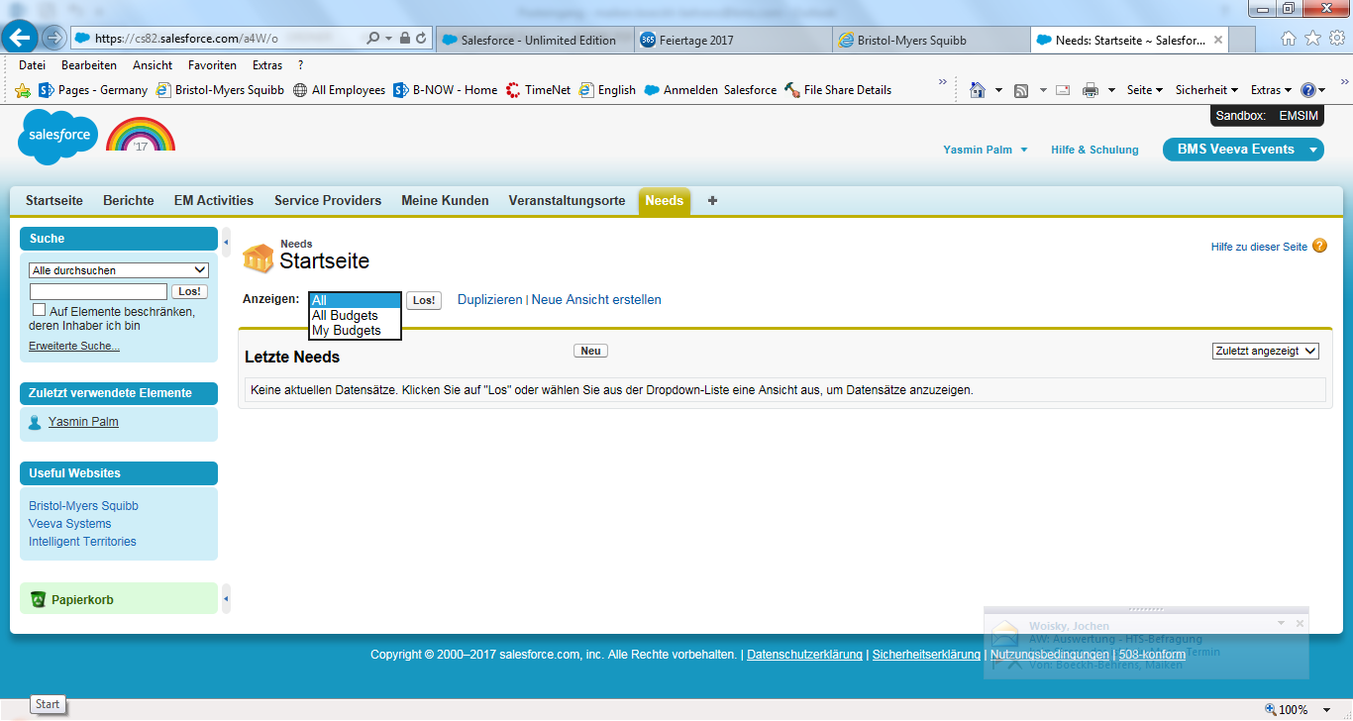

All Budget => ALL needs

My Budgets => My Needs

MNAIDU – 6/1/2017 - Fixed in EUFULL checked an ok (RR060217).

2)

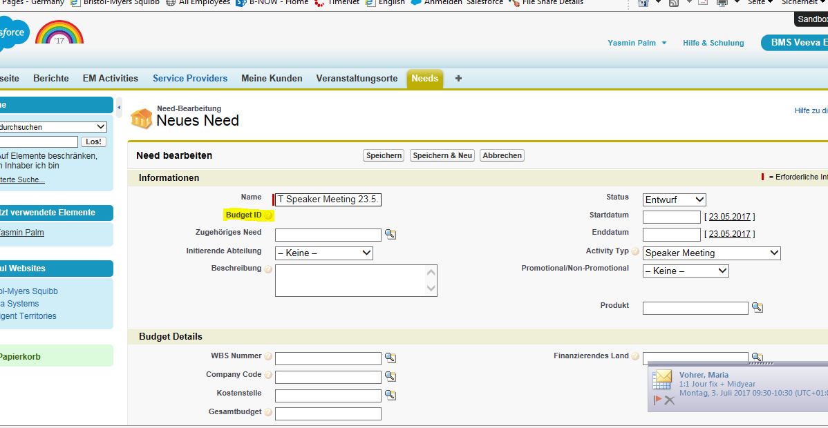

Budget ID => Need ID

MNAIDU – 6/1/2017 - Fixed in EUFULL checked an ok (RR060217).

3)

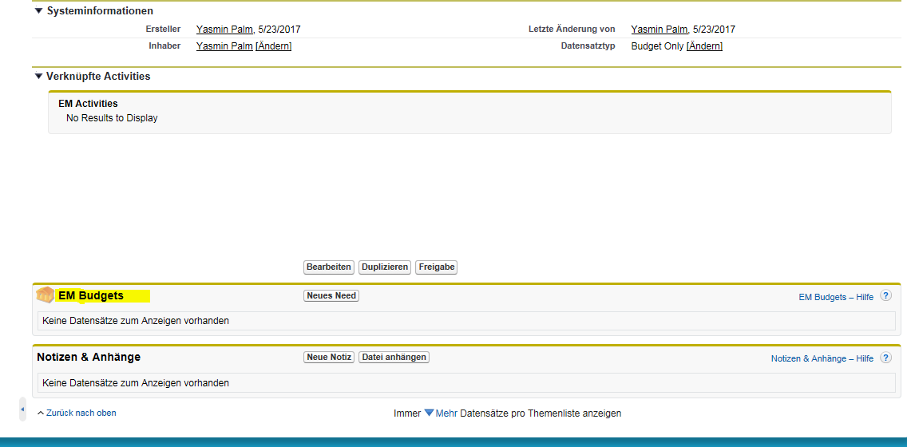

MNAIDU – 6/1/2017 - Fixed in EUFULL – This now reads “Needs” to match what is in Production

EM budgets is still EM budgets; login: christian.grossardt@bms.com.eufull (Medical) – please check again. Screenshot below

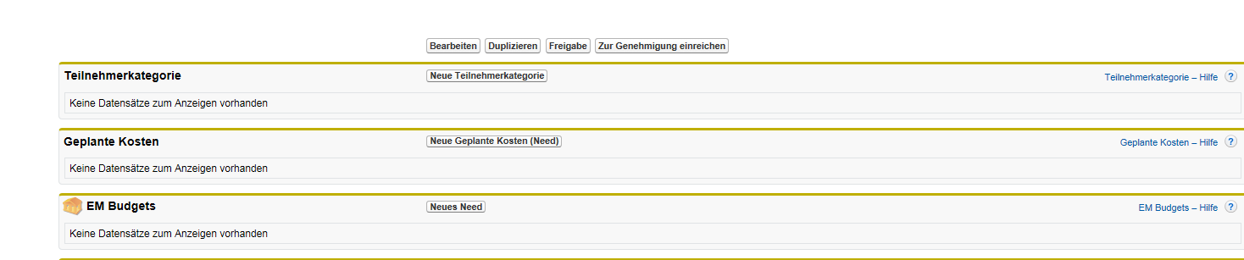

EM Budget => EM Need

4)

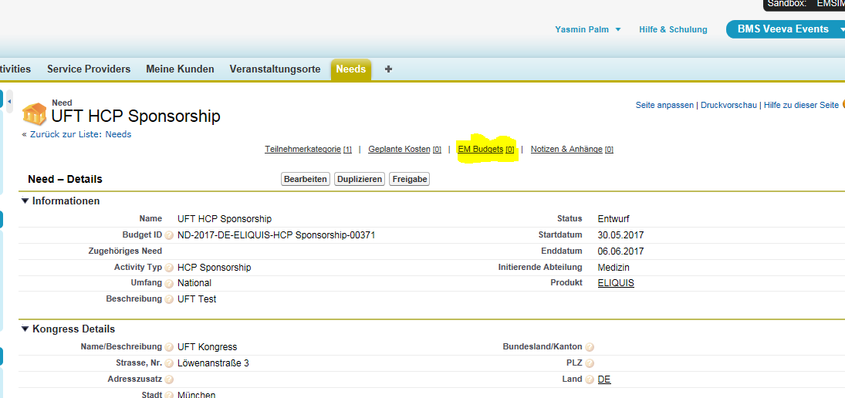

EM Budget => EM Need

MNAIDU – 6/1/2017 - Fixed in EUFULL – This now reads “Needs” to match what is in Production

EM budgets is still EM budgets; login: christian.grossardt@bms.com.eufull (Medical) – please check again. Screenshit below

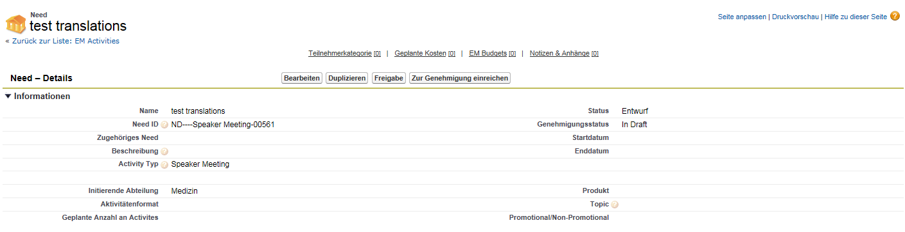

5)

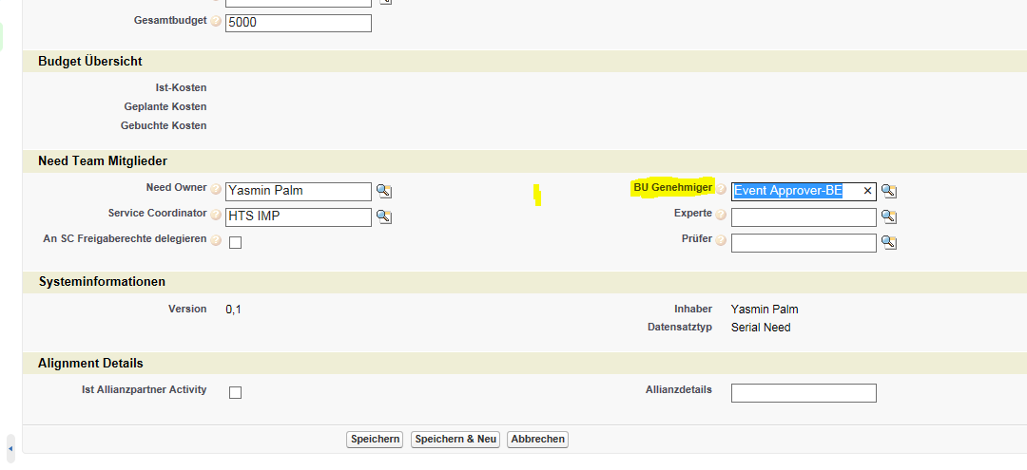

BU Genehmiger => Genehmiger

MNAIDU – 6/1/2017 – Where exactly is this field visible like this? I’m unable to find it on the Need/EM Budget page…see snapshot from EUFULL (which is same as PROD) as *Yasmin Palm*..that field is really just called “Approver” in EUFULL and PROD – that is ok, we adjusted labeling from “BU Genehmiger” to Approver via ticket. No follow up from your side required. (RR060217)

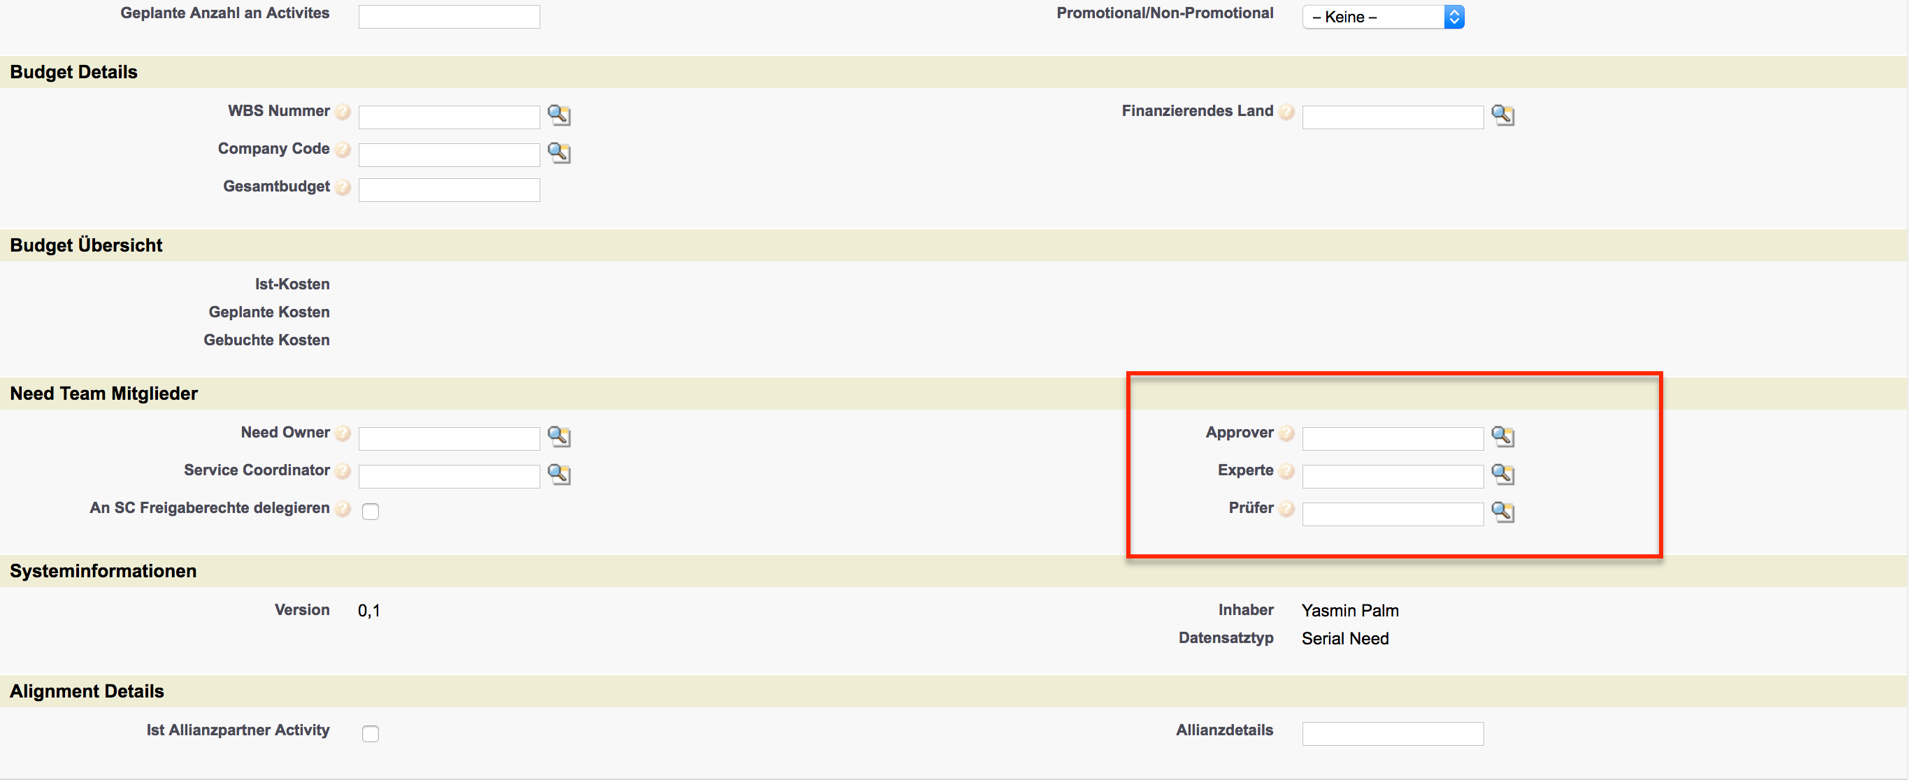

6)

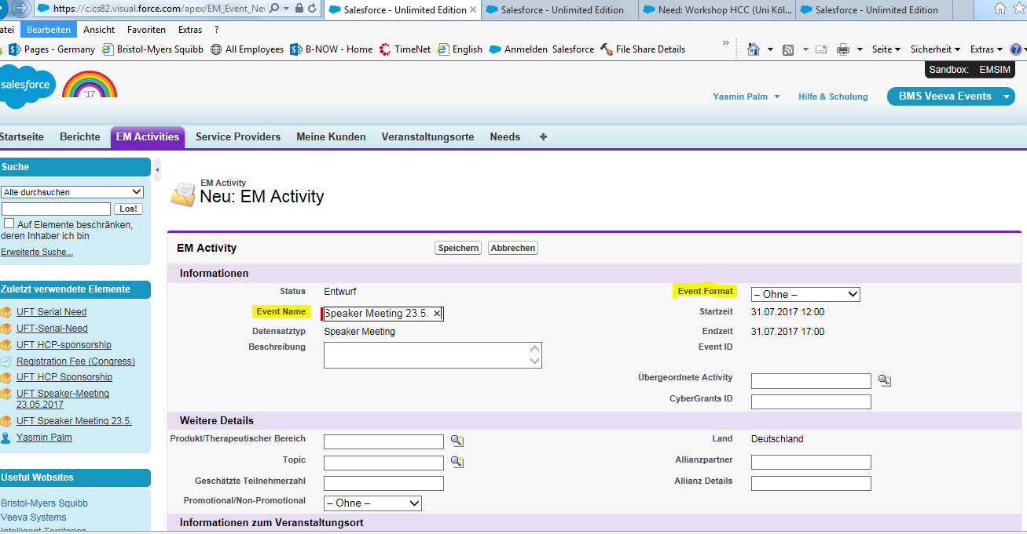

Event Name => Activity Name

Event Format => Activity Format

MNAIDU – 6/1/2017 - Fixed in EUFULL checked an ok (RR060217).

7)

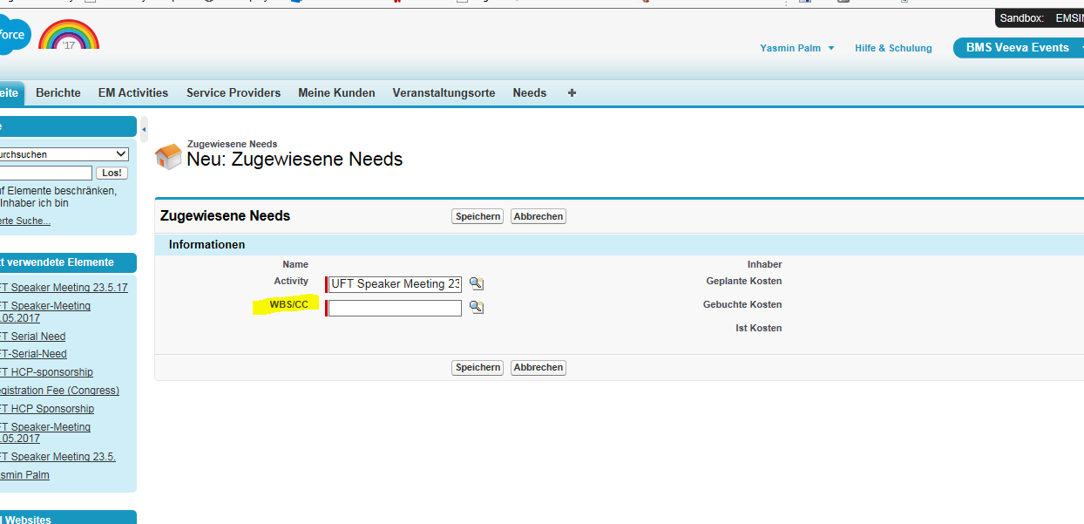

WBS/CC => Need

MNAIDU – 6/1/2017 - Fixed in EUFULL checked an ok (RR060217).

8)

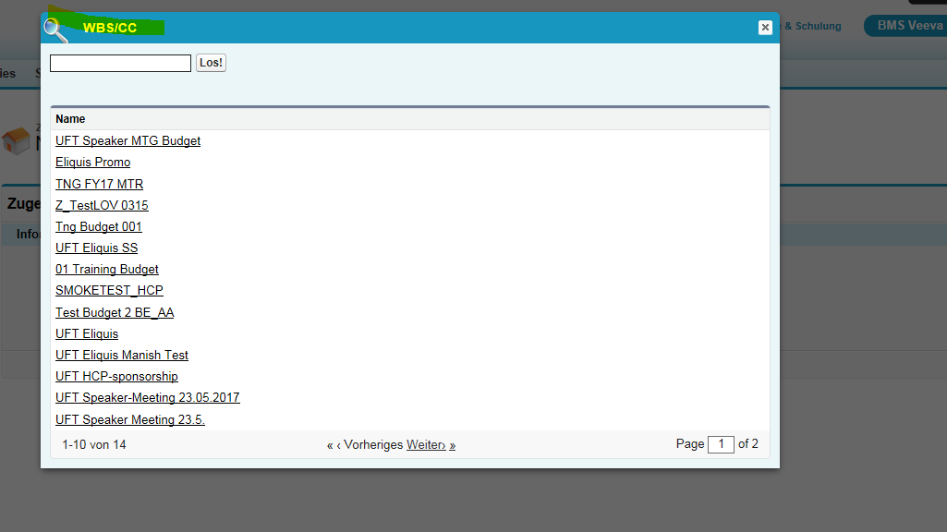

WBS/CC => Need

MNAIDU – 6/1/2017 - Fixed in EUFULL checked an ok (RR060217).

9)

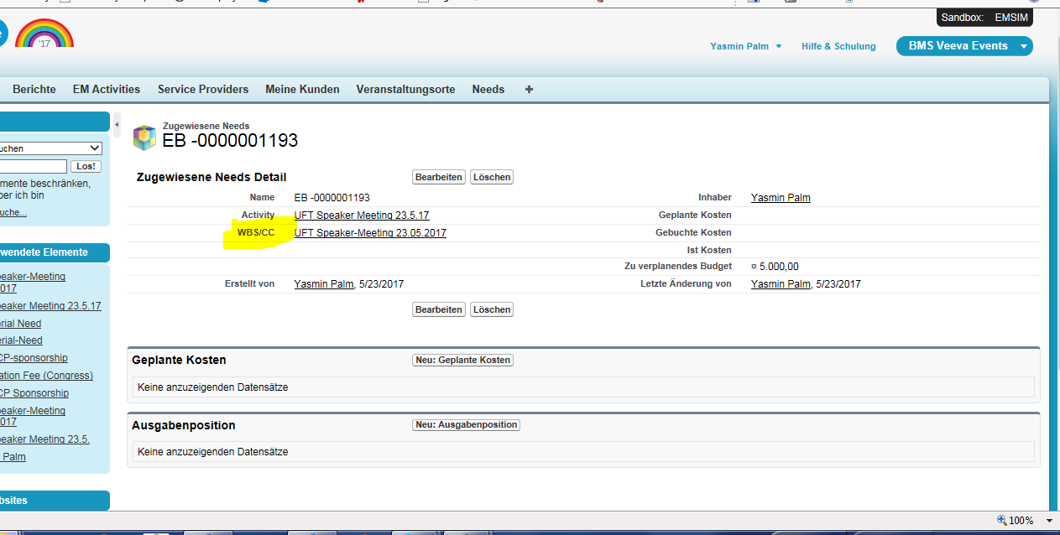

WBS/CC => Need

MNAIDU – 6/1/2017 - Fixed in EUFULL checked an ok (RR060217).

10)

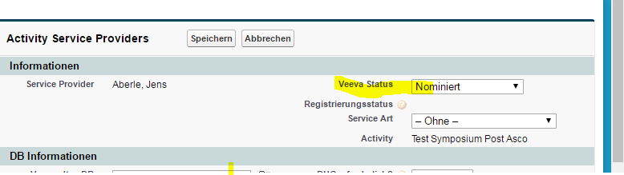

Veeva Status => Status

MNAIDU – 6/1/2017 - Fixed in EUFULL checked an ok (RR060217).

11)

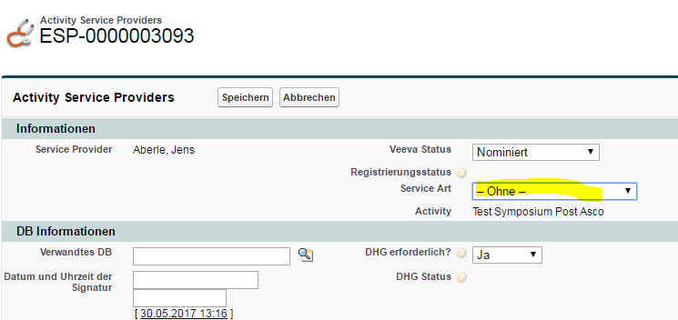

Delete „Fachberater“

MNAIDU – 6/1/2017 – This is unchanged between PROD and EUFULL. Will be managed via prod ticket. No follow up required.

12)

Instead of „Vortrag mehrmalig“ => „Vortrag mit BMS-Slides“

Instead of „Vortrag einmalig“ => „Vortrag mit eigenen Referentenslides“

MNAIDU – 6/1/2017 – This is unchanged between PROD and EUFULL. Will be managed via prod ticket. No follow up required.

13)

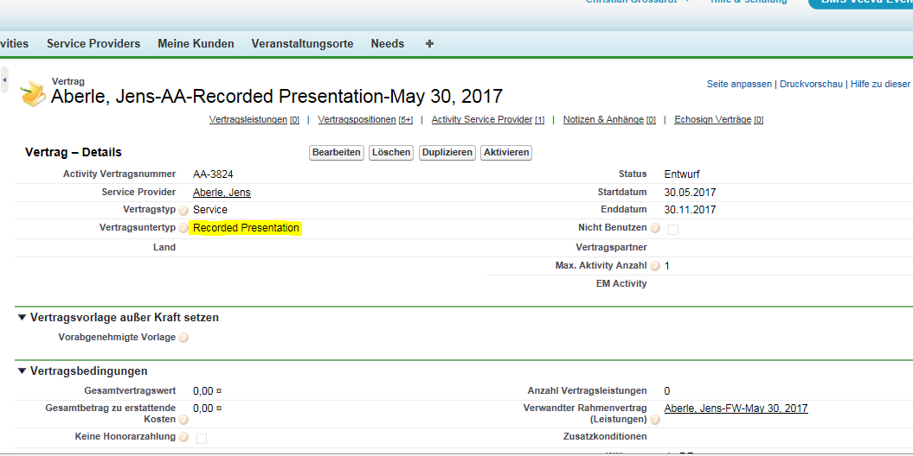

Recorded Presentation => aufgezeichneter Vortrag

MNAIDU – 6/1/2017 – This is unchanged between PROD and EUFULL. Will be managed via prod ticket. No follow up required.

14)

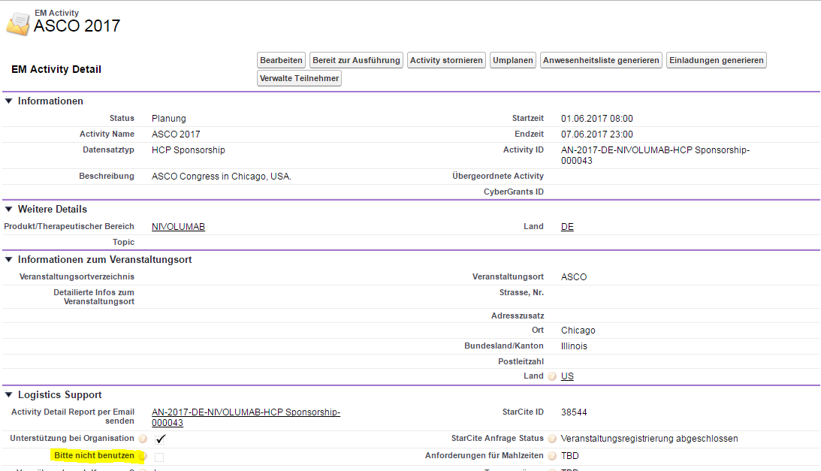

Field „Bitte nicht benutzen“ to be changed into  „Bitte nicht anklicken“.

MNAIDU – 6/1/2017 – This is unchanged between PROD and EUFULL. Will be managed via prod ticket. No follow up required.